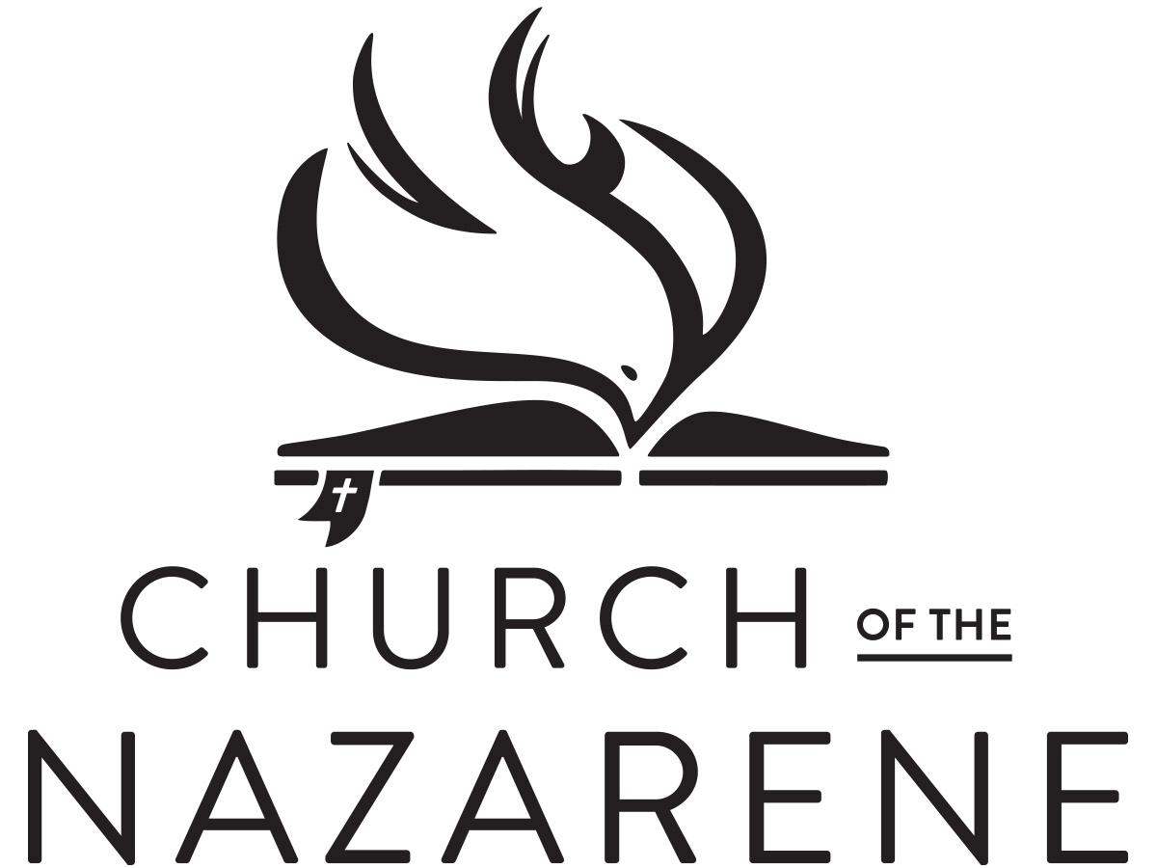

LOCAL MINISTER’S LICENSE

This is to certify that

Is licensed as a Local Minister
in the Church of the Nazarene for one year, provided that
his/her spirit and practice are such as become the gospel of Christ,
and his/her teachings correspond with the established doctrines
of the Holy Scriptures as held by said church.

By Order of the Church Board of the
Your Town Church of the Nazarene.
Done at Your Town, Ohio this 14th day of March, 2030
John Brown
Church Board Secretary
Pastor
LOCAL MINISTER’S LICENSE

This is to certify that

Is licensed as a Local Minister
in the Church of the Nazarene for one year, provided that
his/her spirit and practice are such as become the gospel of Christ,
and his/her teachings correspond with the established doctrines
of the Holy Scriptures as held by said church.

By Order of the Church Board of the
Your Town Church of the Nazarene.
Done at Your Town, Ohio this 14th day of March, 2030
John Brown
Church Board Secretary
Pastor

